Virtual Intelligence Service (VIS) TTP

**Purpose:**

The intention with this document is to provide volunteers in the 132nd VIS role the necessary background and information about the way VIS works in a 132nd context. In addition, the document will help campaign designers/mission makers understand how VIS can be used, and what products are needed from campaign designers/mission makers if they want to use a player staffed by VIS for the campaign.

**Disclaimer:**

The terms and processes described in this document is drawn from real world references, but are simplified and adjusted to meet the need for conducting a campaign in DCS.

**How to read:**

Chapter 1 is the same as in JFACC TTP and the document mirror each other.

Chapter 2 contains a broad and theoretical explanation to provide context and understanding for air campaign planning (how to plan a campaign) and the execution of the air campaign (through the air tasking cycle).

Chapter 3 contains a condensed step by step procedure for JFACC adjusted for planning and executing 132nd hosted campaigns (in line with chapter 2).

Chapter 4: contains best practice for how to organize and work together as VIS volunteers.

VIS for 132nd hosted events can be conducted in 3 (or 2) amibition levels. See section X for ambitions. Theory chapter and terms are describing for the full ambition,and provides the best understanding, but is not needed for ambition 2 or 3.

# Chapter 1: Terms

### End State

A end state is the set of required conditions that defines achievement of all objectives. The end state should account for a wide variety of task the force may need to accomplish. The end state describes the set of conditions to meet the conflict termination criteria (war is over).

### Objective:

The objective is why the mission is being conducted and should be determined first. Objectives may be broad or defined by the end state.

An objective is clearly defined, decisive and attainable. Objectives and their supporting effects provide the basis for identifying tasks to be accomplished.

There are four primary considerations for an objective:

* An objective establishes a single result
* An objective (and associated conditions/effects) should link directly or indirectly to higher-level objectives or to the end state. JFACC participants need to know the higher level objective (CJTF objectives, found in the CJTF operations order) and should be able to identify how their objective support the higher level objective
* An objective is specific and unambiguous
* An objective does not imply ways and/or mean - it is not written as a task

Objectives describe what must be achieved to attain the desired end state.

### Effects

An effect is a physical and/or behavioral state of a system that results from an action, a set of actions, or another effect. A desired effect can be thought of as a condition that can support achieving an associated objective and an undesired effect is a condition that can inhibit progress toward an objective.

Effects describes the conditions related to the objectives:

* Desired effects describe conditions needed to achieve objectives
* Undesired effects describe conditions that will impede achievement of objectives.

### Actions

An action is performance of activity to create desired effects.

### Centre of Gravity (COG)

Center of Gravity: That characteristic, capability, or locality from which a military force, nation, or alliance derives its freedom of action, physical strength, or will to fight.

### Critical Capability (CC)

A means that is considered a crucial enable for a center of gravity to function as such, and is essential to the accomplishment of the specified or assumed objective(s).

### Critical Requirement (CR)

An essential condition, resource and means for a critical capability to be fully operational.

### Critical Vulnerability (CV)

An aspect of a critical requirement (CR), which is deficient or vulnerable to direct or indirect attack that will create decisive or significant effects.

### Tasks

Tasks describe friendly actions to create desired effects or preclude undesired effects.

### Mission

Mission describes the organization’s essential task or task(s) and purpose.

### Target set

A ‘target set’ is a group of interrelated target categories within the enemy system, such as transportation/lines of communication, electric power and adversary media.

### Target category

A ‘target category’ is a group of targets serving the same function, such as bridges, roads, radio broadcasts and newspapers.

### Joint Task Force (JTF)

A force consisting of units from more than one service. For example air, sea and land. All 132nd operations are considered joint operations since they use both air force aviation and naval aviation.

### Combined Joint Task Force (CJTF)

A joint force that includes more than one nation. All 132nd operations are considered combined, since members of the 132nd are from various nations.

### Time Sensitive Target (TST)

Time-sensitive targets (TSTs) are those targets requiring an immediate response because they pose (or will soon pose) a danger to friendly forces or are highly lucrative, fleeting targets of opportunity whose successful engagement is of high priority to achieve campaign objectives. A TST is of such importance that JFC and JFACC is willing to divert assets away from other targets and other missions in order to engage it.

### Apportionment

Air apportionment is Joint Force Commanders way of providing the priority that is to be given to any specific mission type or geographical area at any given time. JFCs normally apportion the air effort by priority or percentage of effort into geographic areas, against mission-type orders, and/or by categories significant for the campaign. These categories can include, but are not limited to, strategic attack, interdiction, counter air, maritime support, and close air support.

### Master Air Attack Plan (MAAP)

A plan that contains key information that forms the foundation of the joint air tasking order. Sometimes referred to as the air employment plan or joint air tasking order shell. Information that may be found in the plan includes joint force commander guidance, joint force air component commander guidance, support plans, component requests, target update requests, availability of capabilities and forces, target information from target lists, aircraft allocation, etc.

### Air superiority

Local air superiity

### Air supremacy

Fire Support Coordination Measures (FSCM)

## Roles

### Joint Force Commander (JFC) (Mission Designer)

JFC is the commander of a JTF or a CJTF. JFC will provide the overall guidance and mission to all components (land, sea, air and special operations).

### Joint Force Air Component Command (JFACC) (Player volunteers)

Joint Force Air Component Command (JFACC) is the headquarter of the Joint Air Forces in the operation (Both Navy and Air Force, so for us in the 132nd, all air forces)

JFACC plans and executes air campaigns. JFACC have a role both in campaign planning for a campaign, but also for the planning for each ATO day (each event)

The JFACC role is about giving the direction and guidance for air operations. JFACC will publish its guidance before each event in the Air Operations Directive (AOD), and this direction and guidance will be used by everyone involved, especially AWACS controllers and mission commanders/flight leads for planning packages or flights.

JFACC also holds responsibility as Airspace Controlling Authority (ACA) and Area Air Defense Commander (AADC) for any 132nd campaign.

If needed JFACC may also request support from other component commands (Land, Sea and Special Operations).

### Virtual Intelligence Directorate (VID) (Mission Designer)

VID provides intelligence injects into the campaign. This can be considered a broader intelligence agency than VIS. VID is the way the mission designer can inject relevant or irrelevant information into the campaign, that can be picked up by VIS and JFACC and used for the execution of subsequent events based on the new information.

### Virtual Intelligence Service (VIS) (Player volunteers)

The VIS role is about providing intelligence for the rest of the organization. The individuals functioning as VIS will try to make sense of the battlefield based on the reports from pilots after events, in addition to intelligence from VID.

VIS has a dual purpose:

1. Support the event planning on a higher level (support to JFACC)
2. Support the event planning on a tactical execution level (support to pilots)

VIS may have intelligence gaps, and can request submit a IR (Information Requirement) to JFACC. JFACC may task specific flight with providing the information asked about in the information requirement.

### Land Component Command (LCC) (Mission Designer)

This is the land component of the Joint Force, and controls the fight taking place on the ground. The land forces are slow to maneuver, but are often the decisive factor. MCC and JFACC will often have a supporting role to help LCC reach their objectives.

### Maritime Component Command (MCC) (Mission Designer)

This is the maritime component of the Joint Force, consisting of surface ships, submarines. Naval aviation is for the 132nd purposes controlled by JFACC. Surface ships operating together may form a Surface Action Group (SAG) with mutual support. MCC may have several SAG`s. Maritime units are fewer in number than land units, and can easily be task organized in various SAG formations based on the need for the specific mission.

### Special Operations Component Command (SOCC) (Mission Designer)

This is the special operations component of the Joint Task Force. Special operations can be used for sensitive missions, or demanding missions that LCC is not suited for. Typical insertions deep behind the enemy line to provide intelligence, or to support attacks by JTACs.

## Products

**Air Campaign Planning Products:**

Air campaign planning products are provided or created prior to the first event in a campaign:

### Operation Order (Created by mission designer)

The operation order is the overall order from the Joint Force Commander (JFC). It will contain an overall situation, an overview of friendly and enemy forces. It will also contain the mission and the commander’s intent with the operation. Furthermore the operation order contains a broad concept of operation and objectives to be met. The operation order will also list specific tasks to the component commands (Land, Air, Sea, Special operations).

Target audience for the operation order is: JFACC.

### Joint Target List (JTL) (Created by mission designer)

The Joint Target List is a master list of available targets to be attacked during the air campaign. The effects of attaking the various targets varies, but all targets on the Joint Target List is a valid and approved target that have an effect on the progress in the campaign. The Joint Target List is created by VID and provided to JFACC when JFACC starts planning the air campaign.

Target audience for the JTL is: JFACC.

### Special Instructions (SPINS) (Created by mission designer and JFACC)

This is a document used for mission designer and JFACC to provide important information for the campaign and its execution. SPINS are to be read by all pilots and controllers participating on an event.

Target audience for the SPINS is: Everyone involved in the campaign.

### Joint Air Operations Plan (JAOP) (Created by JFACC)

The JAOP is JFACC`s overall plan on how to conduct the campaign. The JAOP will have the mission for JFACC together with JFACC’s intent and the objectives for JFACC. It will contain on the concept of operation through information of what is planned to be conducted during the various phases in the operations. The phases may be given in the Operations Order, but JFACC can add new phases or break down the phases in various sub phases. The JAOP will also include a timeline over the various phases and sub phases. The JAOP is created prior to the first event and will be the guiding document for further events.

Target audience for the JAOP is: Mission designer + all pilots and controllers (to get the big picture)

### Airspace Control Plan (ACP) ( Created by JFACC)

As part of the air campaign planning, JFACC with its responsibility as Airspace Control Authority (ACA) create an Airspace Control Plan that contain all necessary regulations for the use of the airspace during the campaign. The ACP includes transit corridors, routes, navigation points, contact points, initial points, kill boxes, minimum risk routes, fighther areas of responsibility, missile engagement zones. Points/areas in the ACP are used as basis for the creation of the Airspace Control Order (ACO) that supports each Air Tasking Order (ATO).

Target audience for the ACP is: Mission designer + JFACC during execution.

**Air Tasking Cycle Products:**

Air tasking cycle products are provided or created for each ATO day or event in a campaign:

### Joint Force Commander Direction & Guidance (JFC D&G) (Created by mission designer)

When necessary (before an event or a new phase), JFC may see it necessary to provide additional direction and guidance for the overall campaign. This will be published in the JFC D&G document.

Target audience for the JFC D&G is: JFACC.

### Air Directions Directive (AOD) (Created by JFACC)

During the execution of the air campaign JFACC uses the AOD to guide and influence operations and taskings. The AOD is JFACC’s plan broad plan and guidance for the execution of an ATO day. The AOD is an important document as it contains the necessary directions and guidance for AWACS controllers to act in accordance with JFACC intent.

Target audience for the AOD is: Mission designer , AWACS controllers,JFACC(for breaking it down into the ATO) and all pilots flying on that ATO day to get the situational awareness of the situation for that ATO day.

### Air Tasking Order (ATO) (Created by JFACC)

During the execution of the air campaign, the ATO is used daily by JFACC to give detailed taskings to flights and squadrons. The ATO gives information about the mission for each flight that are to be flown that ATO day.

Target audience for the ATO is: Pilots and controllers that are participating on the event for that ATO.

### Airspace Control Order (ACO) (Created by JFACC)

The ATO is supported by the ACO which provide the detailed information regarding the planned use of the airspace for the specific ATO day. The ACO activates already planned points/areas on the Airspace Control Plan (ACP).

Target audience for the ACO is: AWACS controllers and pilots (for flight planning and prepearation)

### Joint Prioritized Target List (JPTL) (Created by JFACC)

The Joint Prioritized Target List (JPTL) is a list of planned targets to be attacked for a specific ATO day. JPTL are added as a annex to the AOD.

Target audience for the JPTL is: AWACS controllers + pilots flying that event to get a better situational awareness.

## Other products

In addition to the products mentioned in the previous section, other products may also be encountered during a campaign:

### Intelligence reports (Created by mission designer or VIS)

VID and VIS (if participating in the campaign) will publish intelligence reports which gives updates to the enemy situation. This is something JFACC need to bring into its planning and decide if they need to change their plans, or change their priorities.

### Concept of operations (CONOP) (Created by mission designer)

From time to time the other components (Ground, Sea, SOF) may provide a concept of their operations. This is provided so JFACC gets a better understanding of the other friendly operations are planned. JFACC can then better figure out they can support the other components. A Concept of operation can also be provided for a specific sensitive operation as ordered by Joint Force Commander (JFC).

# Chapter 2: Theory

## Intelligence

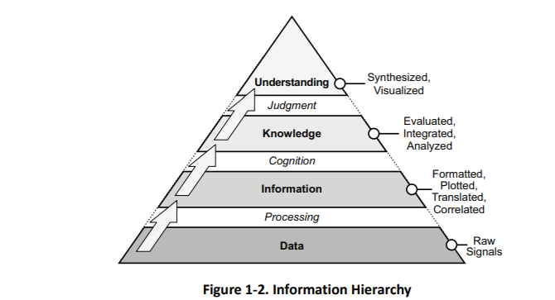

Intelligence cycle

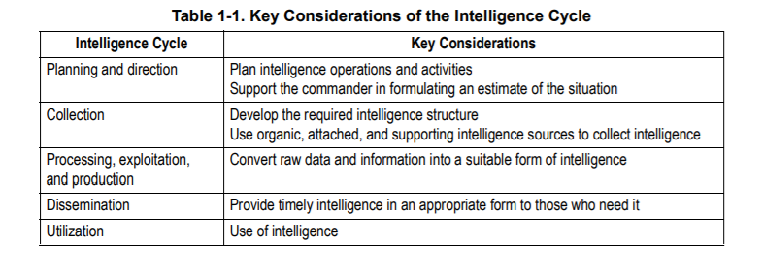

Roles within VIS

* “Big picture”
* “Ground picture”
* “Air picture (+ SAMs)
* “targeting” -> Big picture?

## Air Campaign planning

## Execution of the Air Campaign: Air Tasking Cycle

# Chapter 3: 132nd Flow

In the 132nd, the workflow for JFACC is divided into two major parts. Part 1 is conducted prior to the first campaign mission and the output will be the Joint Air Operations Plan (JAOP). If the campaign goes over a long period of time (many events), then part 1 can also be used to update or refine the plan before a new phase in the campaign is started. Part 2 is the detailed planning conducted prior to each event and the main output is the Air Operations Directive (AOD) and Air Tasking Order (ATO).

**CAUTION:**

It is very easy to get too focused on products and creating the “correct” products and documents. The most important thing for JFACC is to plan and have a plan for the campaign as a whole and specifically for each event. The products are just a way of communicating the plan to everyone involved (Mission designer, AWACS controllers, JTACs and pilots). The best way to plan is to talk together while looking at a map, once plan or concept is agreed upon, then one can use the documents to convey the plan and necessary instructions to everyone involved. With the process explained below, the production of the actual product comes last, and it is important to do the first steps/stages without focusing on the output product (JAOP/AOD)

## Part 1: General concepts

When using JFACC and VIS construct in 132nd events the following guiding principles are effective:

* One ATO Day is divided into several events.
  + This is decided between mission designer and JFACC volunteers
  + Typically one ATO day consist of minimum 2 events
  + The benefit this gives is that the products created for an event is still valid also for the next event and thus, events can be conducted at a more rapid pace. The only artificiality is that for event number two, JFACC will need to create a new ATO to facilitate for the signups on the actual date. But other products such as AOD, JPTL, ACO is still valid with the same information.
* ATO day in a campaign is given the name D1 (for first day of campaign), D2 (second day), etc.
  + If more events are conducted on the same ATO day, then the event number for the day is added:
    - ATO Day 1, event 1: D1.1.
    - ATO Day 1, event 2: D1.2
    - ATO Day 2, event 3: D2.3.

## VIS Ambition 1

Explain the most ambitious ambition for VIS

“big picture”

Air defense / SAM

Ground picture

Support to both JFACC and pilots per event

Campaign planning + support per event

## VIS Ambition 2

Explain the middle ambition for VIS

No campaign planning, only support per event

## VIS Ambition 3

Explain the lowest ambition for VIS

Only support to pilots

## Part 1 Planning: Air Campaign planning

## Part 2 Execution: Air Tasking Cycle (per event)

# JFACC organization

Best practice for JFACC is:

## Air campaign planning

It is recommended that one member of the JFACC team is in charge, as it will be easier to maintain overall understanding and making sure the entire team gets through the process.

## Air tasking cycle:

It is recommended, that one JFACC member is responsible for an ATO, and follow this ATO through the various steps in the air tasking cycle:

In example below, JFACC member 1 is responsible for ATO A to be flown on Day 1 of the campaign. JFACC member 1 will conduct the stages in the air planning cycle sequentially.

For the week where ATO A is flown on Sunday (D1), then JFACC member 2 is preparing the ATO for Day 2 of the campaign, while JFACC member 3 is going through stage 2 in the air tasking cycle and focusing on completing the JPTL and MAAP for the ATO for D3. At the same time JFACC member 4 is going through stage 1 and focusing on the objectives and effects for the ATO scheduled for D4.

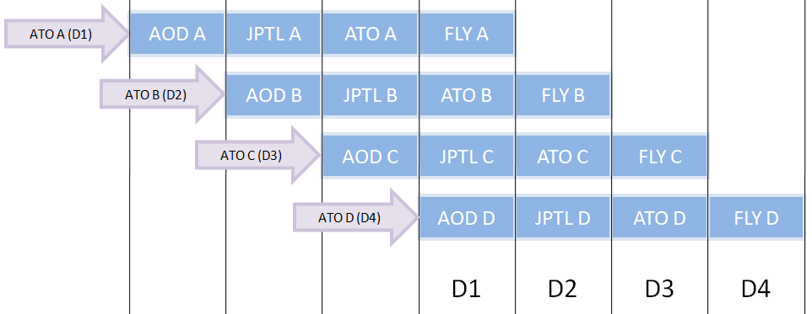

Note that when the different stages take place is not important, and such all steps can be conducted in the same week of the event, or it can be spread out over more weeks. This is intended to facilitate for people having different schedules and different ability for the effort needed to plan for the event.

# ANNEX

## Annex 1: Worksheet for understanding objectives

Objective (XX)

Identify the enemy activity to be affected (**WHAT** do we want to do?)

Answer:

Identify the target system(s) performing the activity (Against **WHOM?)**

Answer:

Identify the specific location where enemy activity should be modified (**WHERE** do we want to affect the enemy activity)

Answer:

Determine the opportune time and duration to impact the enemy (**WHEN** and for **HOW LONG** do we want to impact the objectives?)

Answer:

Identify logical, available assets that can reach the objective target(s) within time constraints (**HOW** do we want to reach the objective).

Answer:

State attainable, quantifiable criteria against which effectiveness/success will be measured (**TO WHAT DEGREE** do we want to reach the objective)

Answer:

Perform cost analysis to estimate the cost versus potential benefit. (**HOW MUCH** will it cost to reach the objective, and is it **WORTH** it?)

Answer:

Check the objective against all known guidance. (**WHY** do we want to reach the objective?)

Answer:

### Example

Objective 1: Destroy Country X capability of using weapons of mass destruction

Identify the enemy activity to be affected (**WHAT** do we want the enemy to do?)

**Answer:**

* Stop production of chemical weapons
* Unable to deliver WMD toward friendly countries.

Identify the target system(s) performing the activity (Against **WHOM?)**

**Answer:**

* 361st SCUD Battalion
* Chemical weapon storage in location A
* Chemical weapon storage location B
* Chemical weapon research facility A
* Chemical weapon production facility B

Identify the specific location where enemy activity should be modified (**WHERE** do we want to affect the enemy activity)

**Answer:**

* 361st SCUD Battalion deployed to Desert Y
* Chemical weapon production facility B located in city X.

Determine the opportune time and duration to impact the enemy (**WHEN** and for **HOW LONG** do we want to impact the objectives?)

**Answer:**

* WMD delivery means: As soon as possible
* Chemical weapon factory B: As soon as possible, out of action for 6 months.

Identify logical, available assets that can reach the objective target(s) within time constraints (**HOW** do we want to reach the objective).

**Answer:**

* AR mission to locate and destroy 361st SCUD Battalion in desert Y
* Strike mission against chemical weapon production factory

State attainable, quantifiable criteria against which effectiveness/success will be measured (**TO WHAT DEGREE** do we want to reach the objective)

**Answer**:

* 361st SCUD BN: 8 of 8 SCUD TEL destroyed
* Chemical weapon production factory: Entire building collapsed

Perform cost analysis to estimate the cost versus potential benefit. (**HOW MUCH** will it cost to reach the objective, and is it **WORTH** it?)

**Answer:**

* AR mission against 361st SCUD BN in desert Y: Low threat, single flights can be tasked to search and destroy SCUD
  + Destroying the SCUD BN will eliminate the threat from chemical weapons from country X as without them, Country X will have no means of delivering the chemical weapons against friendly countries.
* Strike mission against chemical weapon production factory: Heavily defended city, air defenses need to be attacked and suppressed prior to any attack. High risk mission due to threat Large complex, so many aircrafts needed. A large package needed.
  + Destruction of the factory prevents a critical chemical needed for the weapons of mass destruction to work, and if the factory is destroyed, country X will not be able to produce any more chemical weapins

Check the objective against all known guidance. (**WHY** do we want to reach the objective?)

**Answer:**

Prevent weapons of mass destruction of being used against friendly forces.

## Annex 4: Target priorities

Priority A

* The target is essential for mission success in support of current objectives (or is a designated a Time Sensitive Target (TST).
* It is crucial to the overall success of the operation.
* It will have immediate and compelling effects.
* Its timeliness as an urgent target may not exist in the future.
* If not targeted, negative consequences may seriously jeopardize future CJTF operations

Priority B:

* Targets have substantial, but not immediate impact on the battle.
* The cascading effects this target provides may not be realized in the future.
* If not targeted on this ATO, a significant level of effort may be required later.
* If not targeted, negative consequences may significantly hamper CJTF operations.

Priority C:

* It will contribute to the battle, but it is not critical to mission success.
* It will further the success of the operation.
* It will eventually require targeting due to JFC future plans.
* If not targeted on this ATO, negative consequences will probably not impede operations.

Priority D:

* Target of opportunity if:
  + A) Other targets not suitable for this ATO.
  + B) As a backup target
* It will have minor contributions to the operation.
* It may be required for targeting, but is not time critical.
* If not targeted, no negative consequences

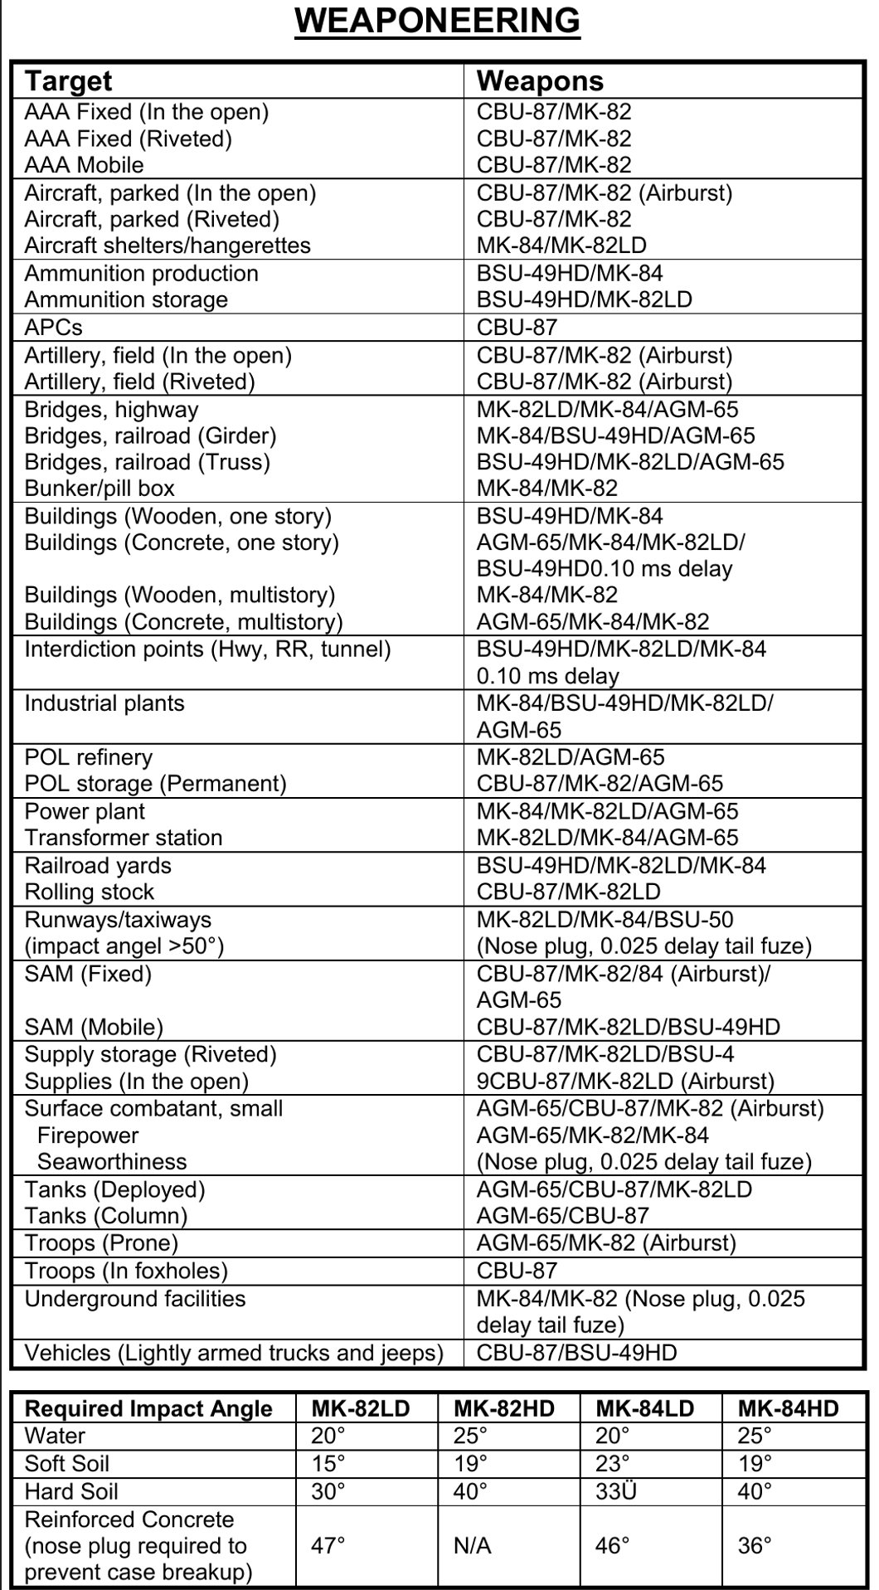

## Annex 6: Aircraft to tasking

A table with suggested tasking for the various aircrafts

Plus and minus with each aircraft per tasking?